# **Team 4 Design 1 Resort Management**

By:Axel Arellano, Farhan Mohammad, Nick Bloom,

Rakesh Chandraraj, and Zhiyuan Zhang  
*Github:https://github.com/zzhiyuan59/CS3704*

# **Notification: (1) All Diagrams can be referenced at an enhanced resolution at the above github link with Draw.io interface. (2) Based on principle for easy reading, each member Design classes may contains different different field and function in each part; However, it is easy converted but hard to read, so we decide to keep each Class to be separated. Class Diagrams:**

**Reservations Diagram (Axel):**

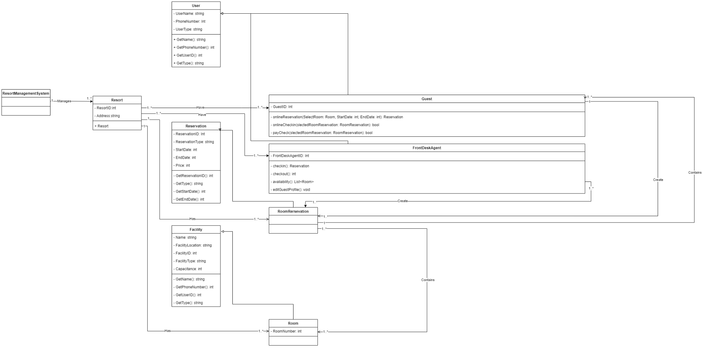

**Guest Home Experience Diagram (Farhan):**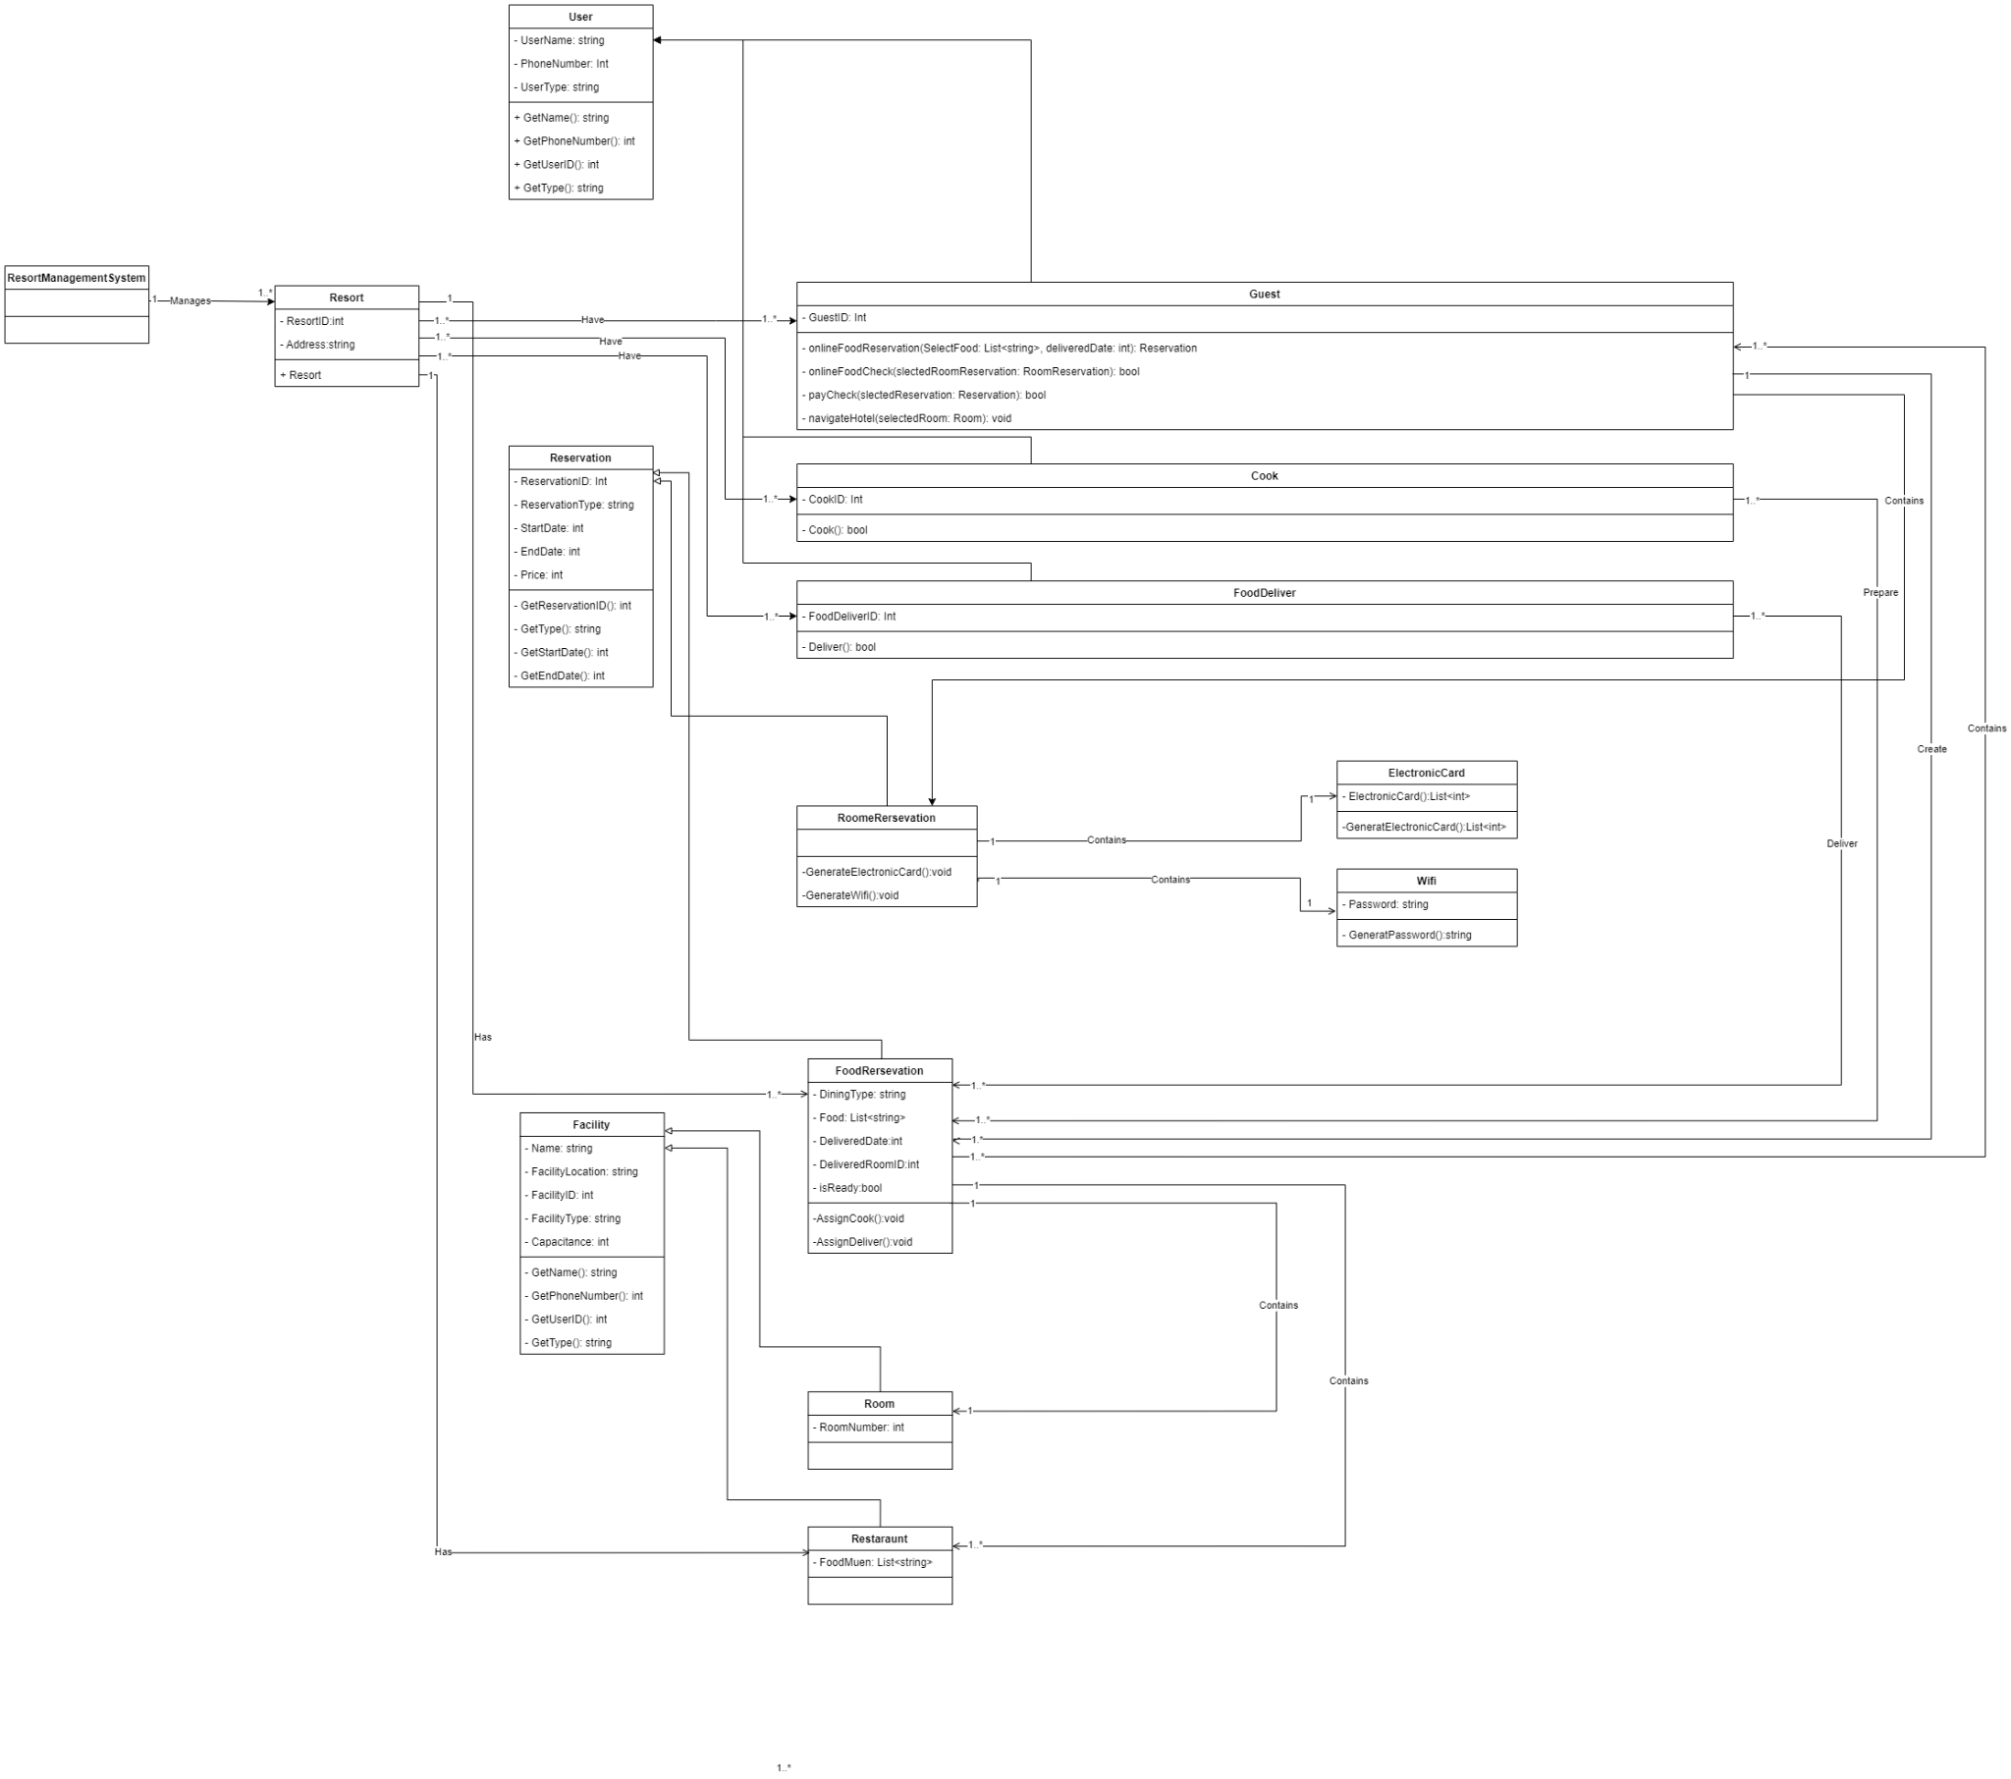

**Staff Management/Tools Diagram (Nick):**

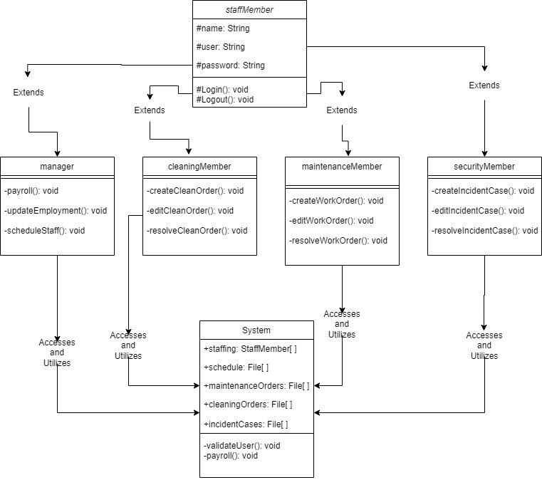

**Customer Service Functionality Diagram(Rakesh):**

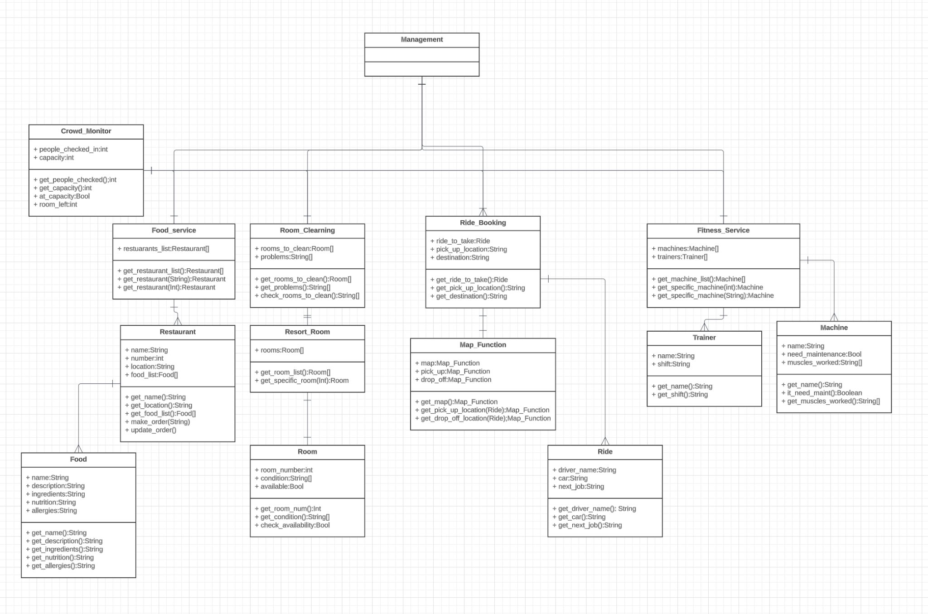

**User Account Management Diagram (Zhiyuan):**

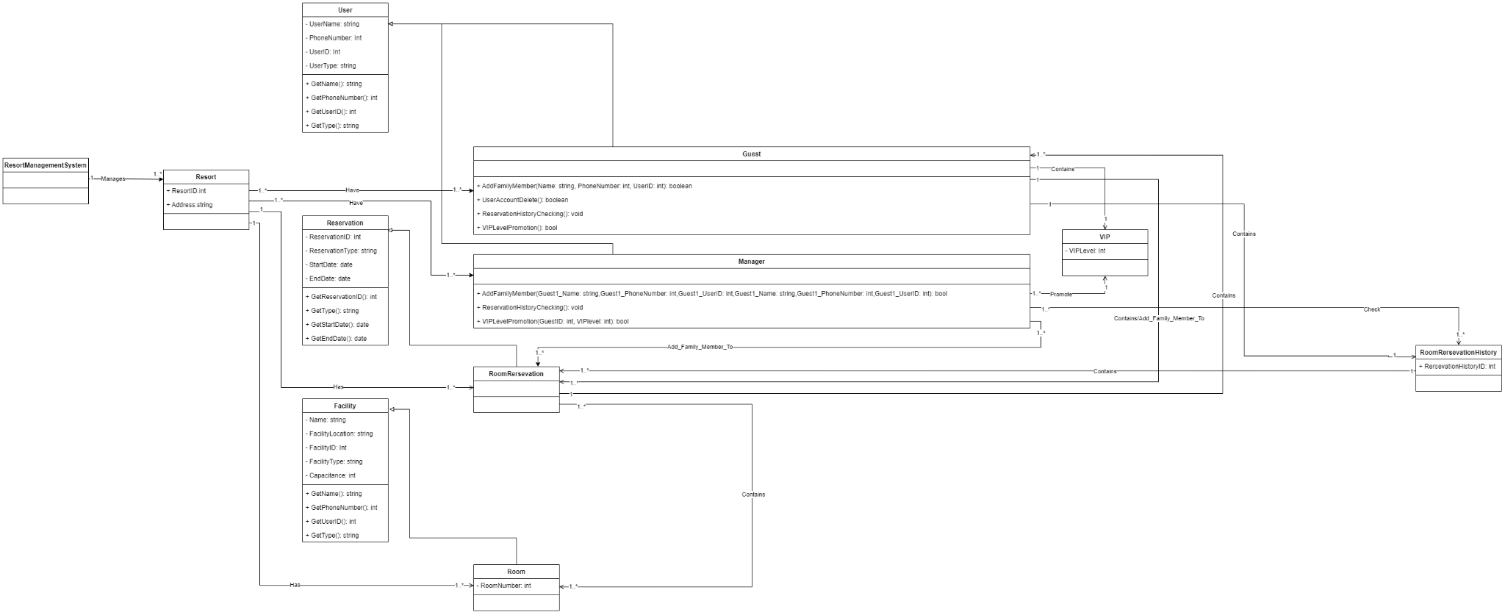

# 

# 

# **ER Diagram:**

**Reservations Diagram (Axel):**

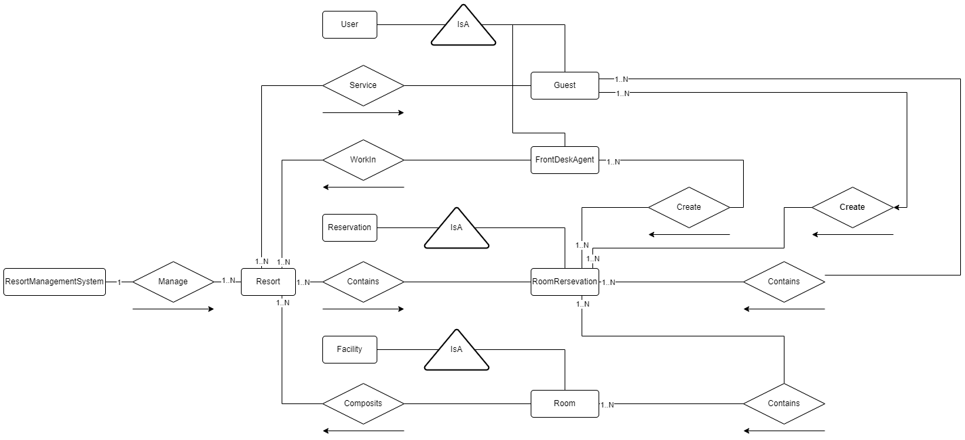

**Guest Home Experience Diagram (Farhan):**

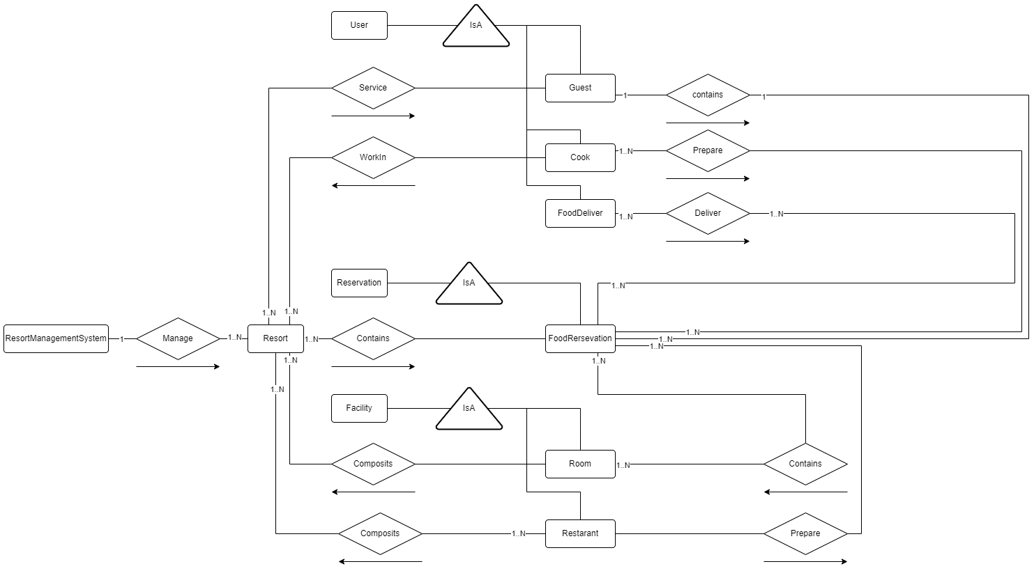

**Staff Management/Tools Diagram (Nick):**

Pt.1

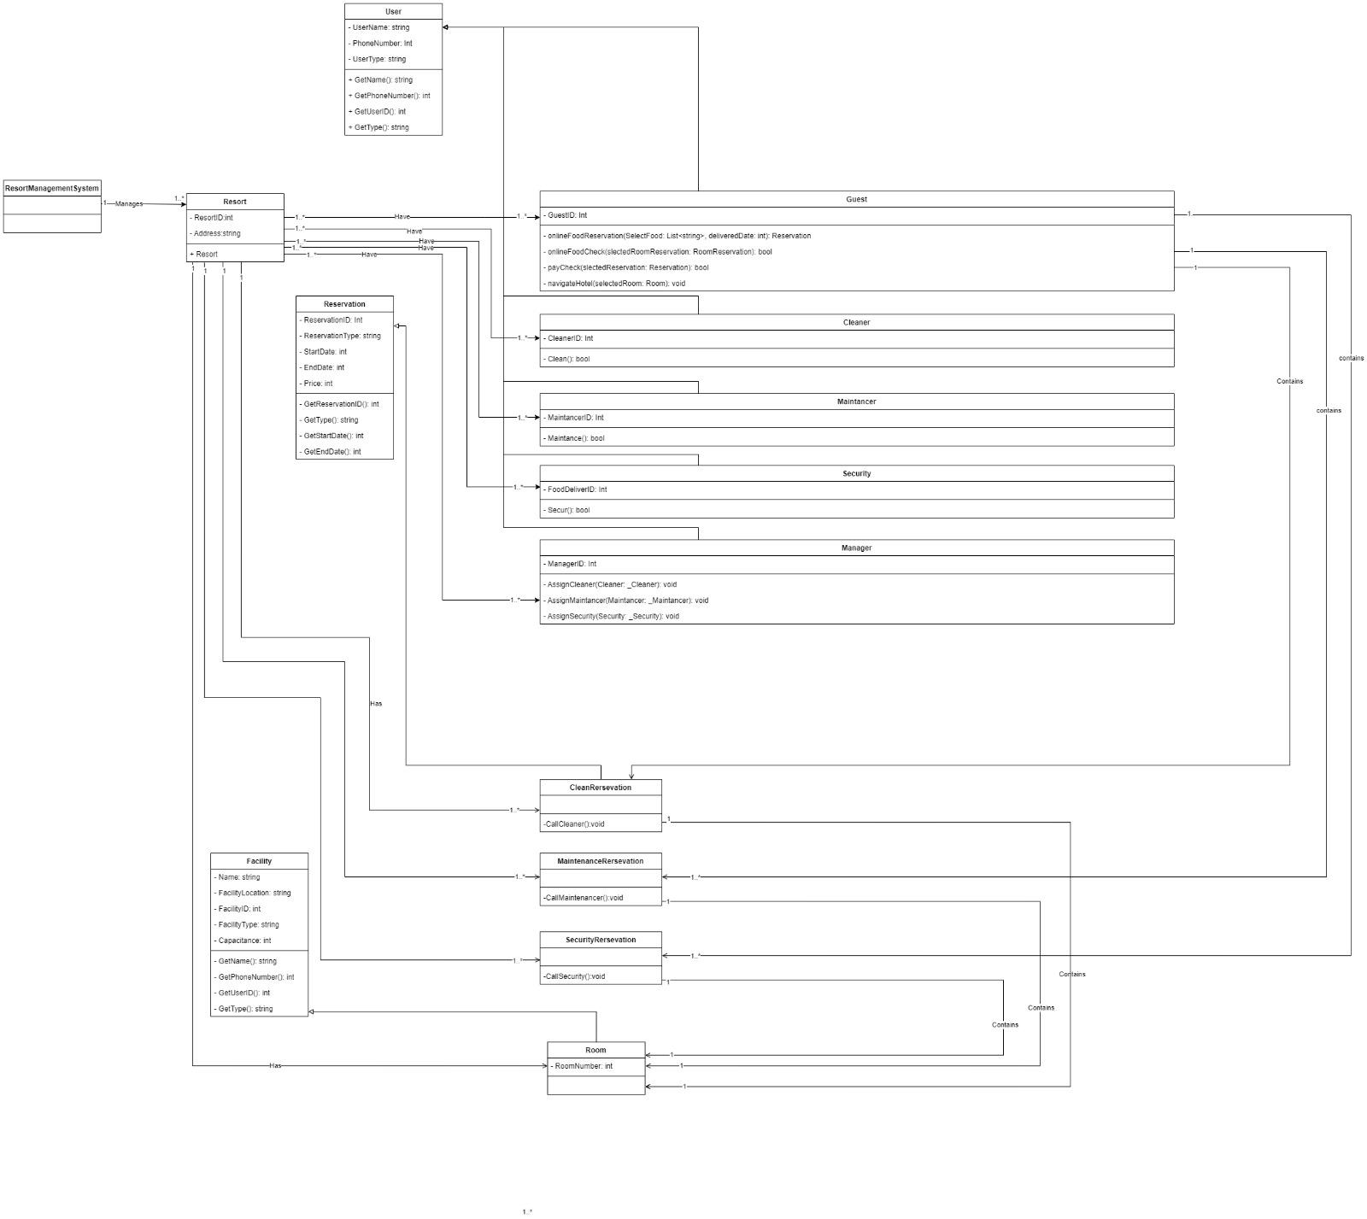

Pt. 2

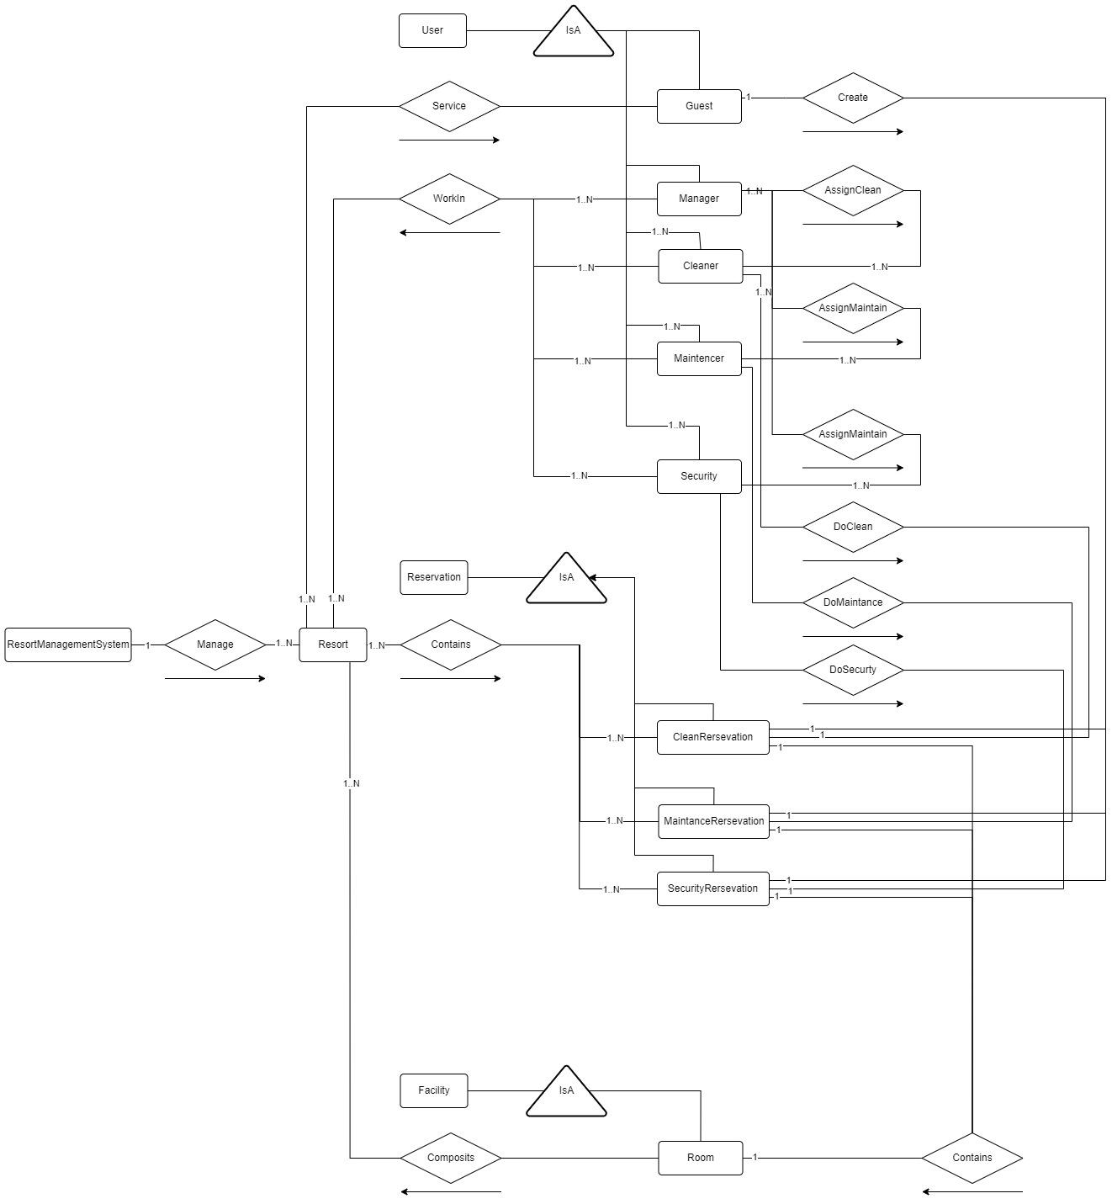

**Customer Service Functionality Diagram(Rakesh):**

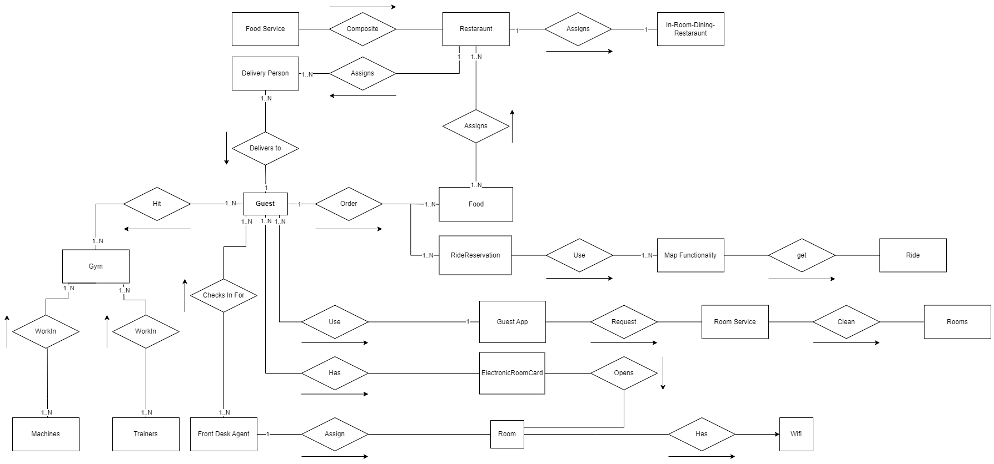

**User Account Management Diagram (Zhiyuan):**

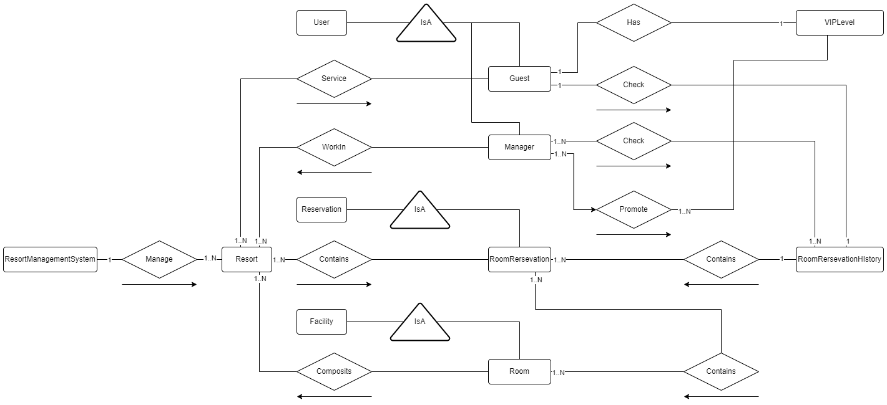

# 

# 

# 

# 

# **Tables:**

**Reservations (Axel):**

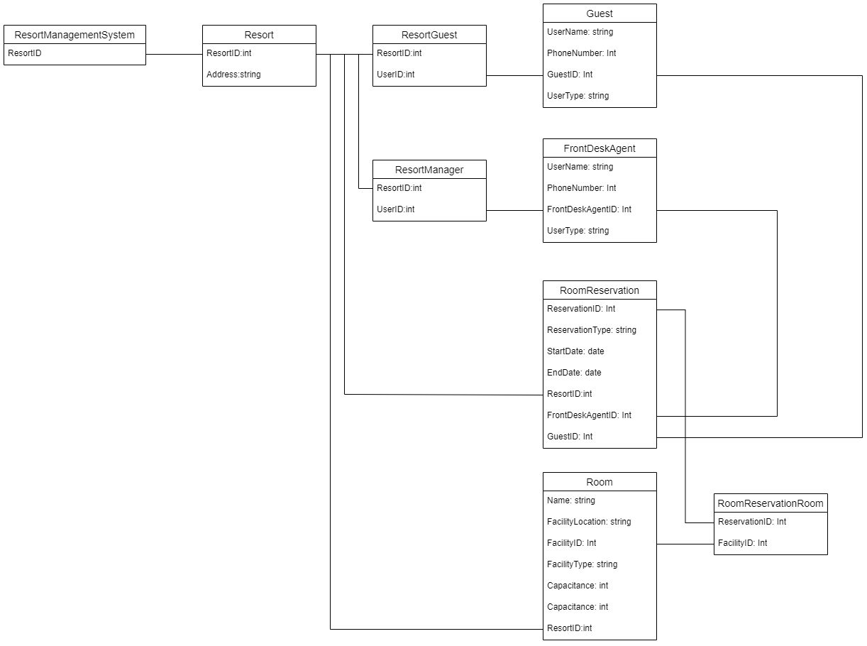

**Guest Home Experience (Farhan):**

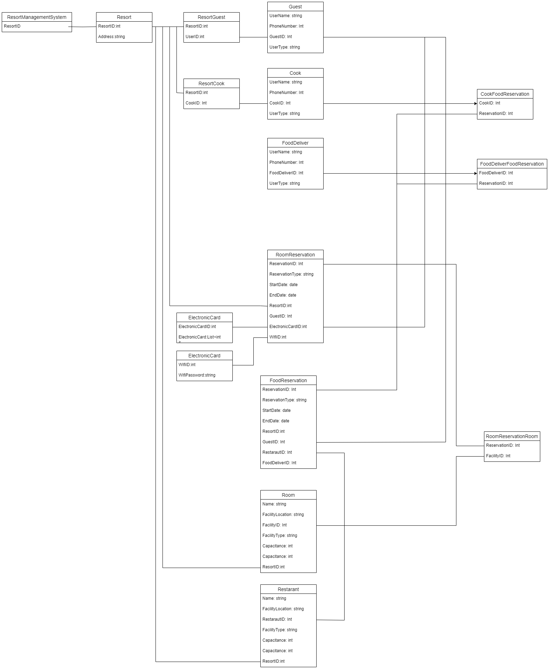

**Staff Management/Tools (Nick):**

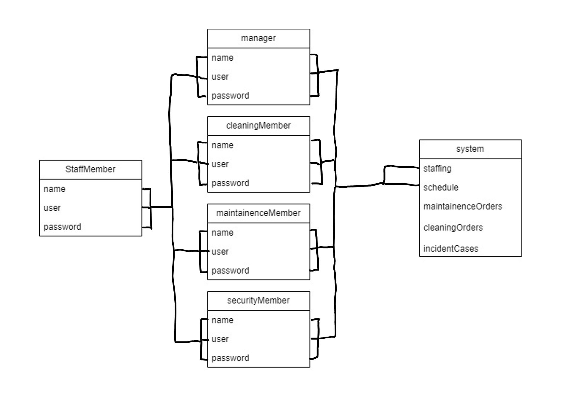

**Customer Service Functionality (Rakesh):**

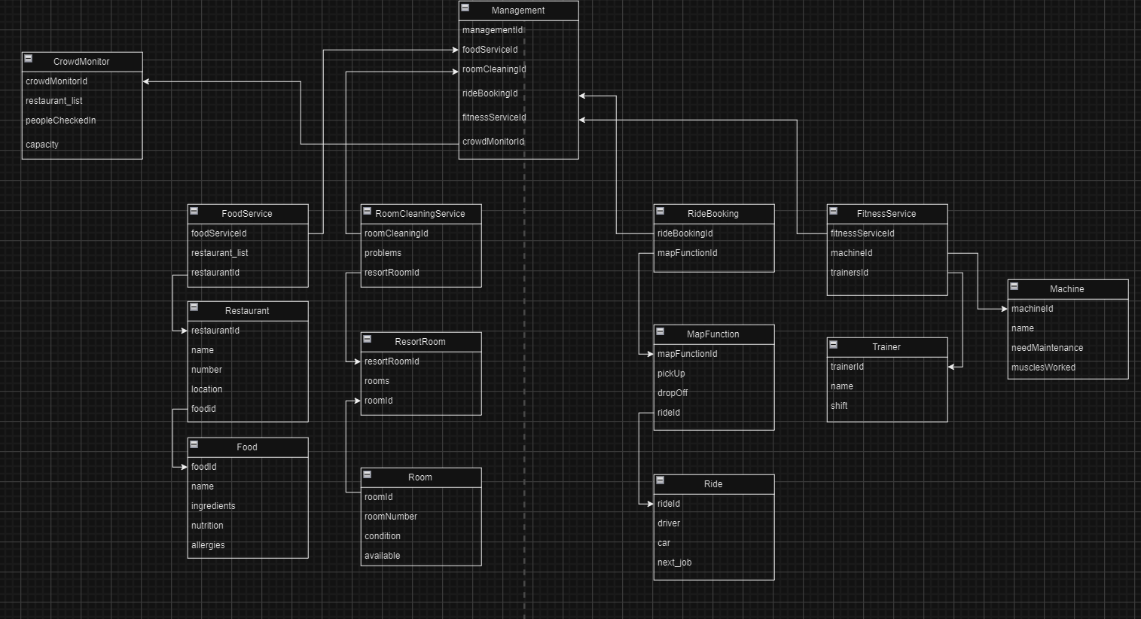

**User Account Management (Zhiyuan):**

